ENTRY FORM
Autoklub RAC Sedlčany
Areál Sedlčanská kotlina 107
26401 Sedlčany
Email: setkani-mistru@email.cz
www.setkani-mistru.cz
20.9 2015 Sedlčany CZE
WORLD CHAMPIONS MEETING
STATEMENT:
„I have read and understand the actual regulations of World Champions Meeting in Sedlčany 2015 and I will ride at my own risk.“

Surname
1st name
Street and number
Zipcode
City
Country
Date of birth
Phone number
Fax number
Email address
Personal insurance | Yes
Entry form fill in by computer and send by mail setkani-mistru@email.cz or fill in by handwriting and send by fax or post mail.

Class | Brand of bike | Year of construction
35+
50+
60+
66+
70+
Veteran
Start number

a |  | mm
b |  | mm
c |  | mm
d |  | mm
Lo |  | mm
L |  | mm
Rear suspension |  | mm
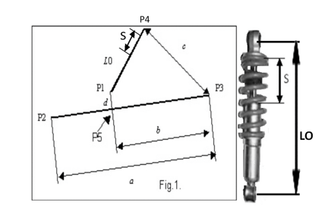
Data of the bike You are obliged to fill in and to demostrate these data at technical inspection
Rear suspension max. 130 mm
Signature
………………………

